**The Fitness Club**

**End Term Report**

**By**

**Sarvjeet Singh(K19KX17)-11912936**

**Monika Kumari(K19KX16)-11912237**

**Niladri Roy(K19KX18)-11913815**



**School Of Computer Science Engineering,**

**Lovely Professional University, Jalandhar,**

**April 2020**

**Student Declaration**

This is to declare that this report has been written by us. No part of the report is copied from other sources have been duly acknowledged. I/We are aware that if any part of report is found to be copied, I/We Shall take full responsibility of it.

Sarvjeet Singh

17

Monika Kumari

16

Niladri Roy

18

LPU, Jalandhar

10-April-2020

**Table Of Content**

**SR No. Tittle Page No**

1. **Introduction 05**
2. **Description 06**
3. **Screenshot Of Project 07**
4. **Technology Used 13**

**BONAFIDE CERTIFICATE**

Certified that this project report The Training Club(Gym) is the bonafide work of Sarvjeet Singh, Monkia Kumari and Niladri Roy who carried out the project work under my supervision.

Amandeep Kaur

**Introduction**

HTML is the combination of Hypertext and Markup Language. Hypertext defines the link between the web pages. Markup Languages is used to define the text document within a tag which defines the structure of web pages. We are making a project on the GYM(The Training Club). The main purpose to develop this project is to have the healthy , fit and stress free Body Which will help people to stay active for there daily task.

**Outcome:-**

The main objective is to stay fit and healthy in a simpler way. This Project is useful for the people who are struggling with low body mass or high body mass, stress and anxiety. As the user we register with us we will assign a Trainer to him/her who will take care of there diet, body and mind to make them fit from body and brain.

**Project Description**

This Project made to get fit and stress free mind by conducting schedule for their training and diet. This project will help them to get good personality and good behaviour and ofcourse body.

This project allows user to make the schedule by providing how many days they can workout in week for how long and then their diet also. They get their own Trainer who makes this plan and help them to achieve their Goal. They will provide their Phone No. , Email Id for conatcing them.

**Module:-**

**Home Page :-** Designed By Monkia Kumari, it has all the button for traversing through the website.

**Login/Register Tab :-** Designed By Niladri Roy.

**About Us, Time Table& Training, Gallery:-** Designed By Sarvjeet Singh.

**Screen Shots Of The Project**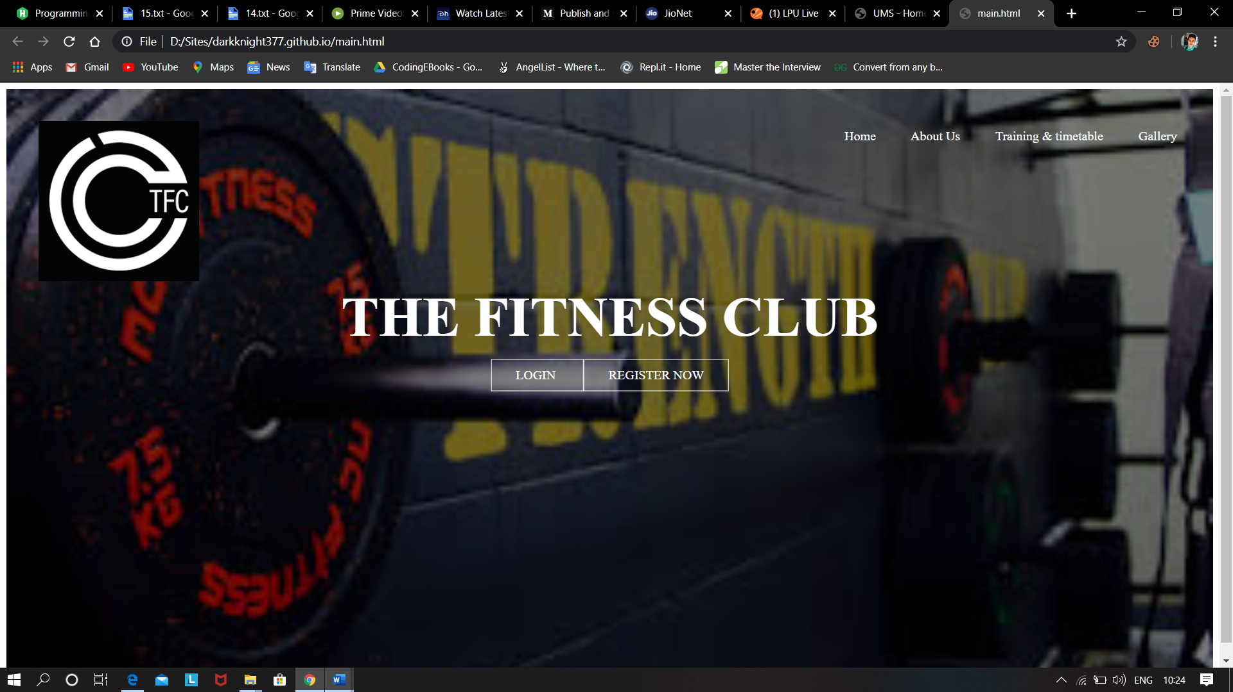 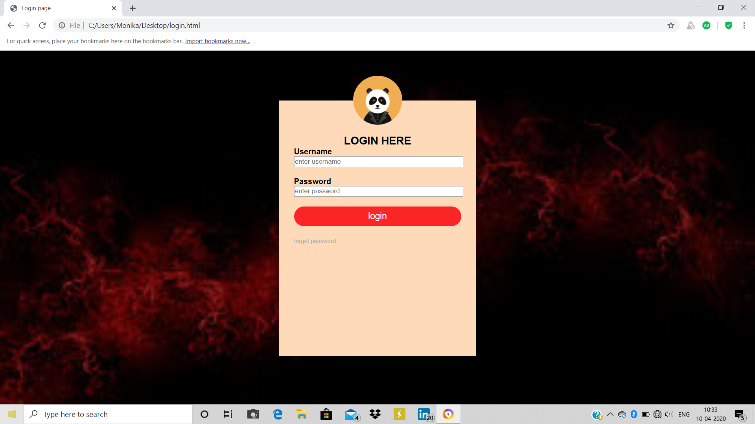 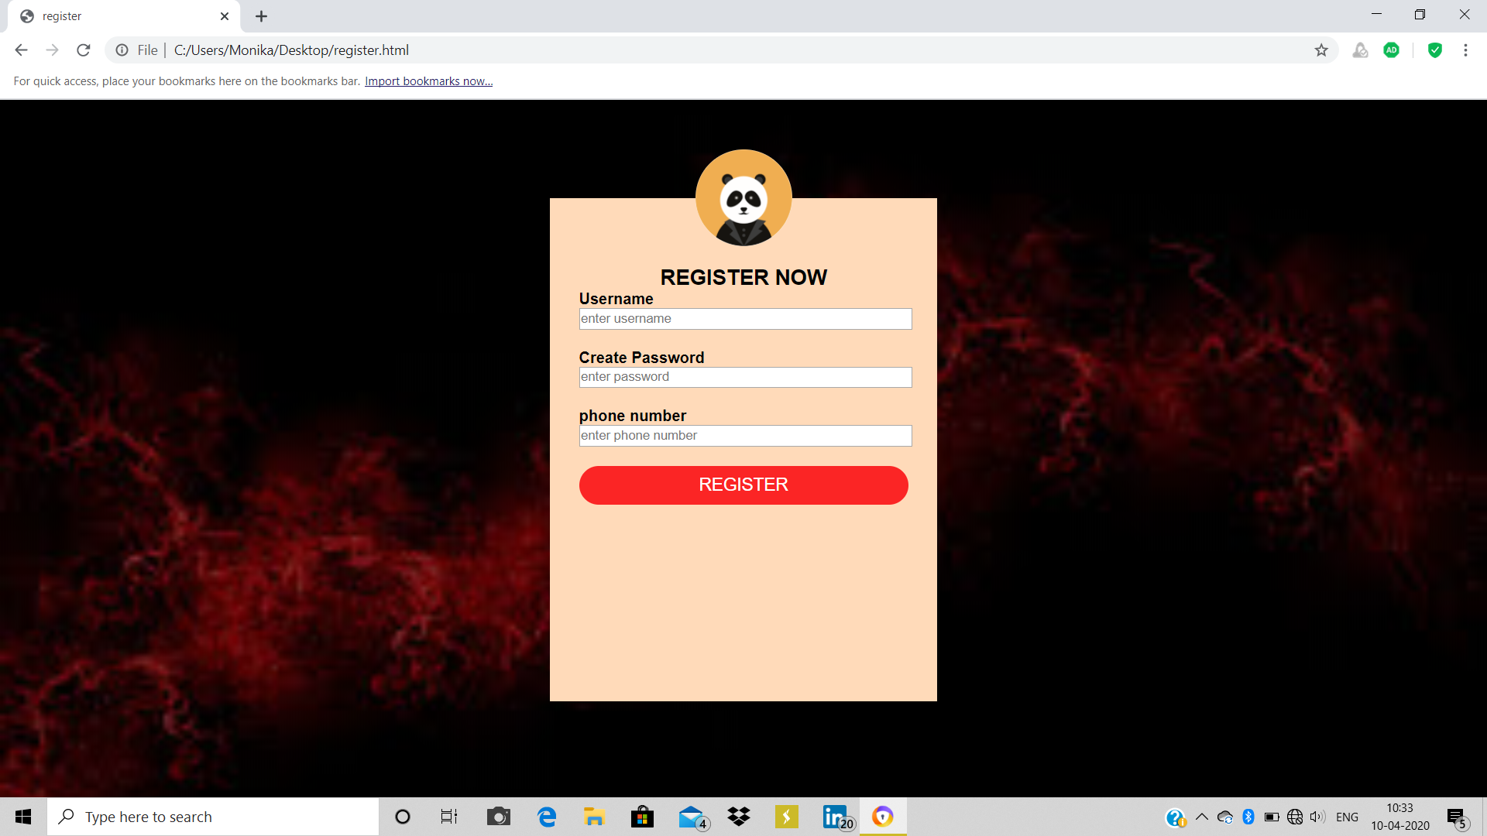

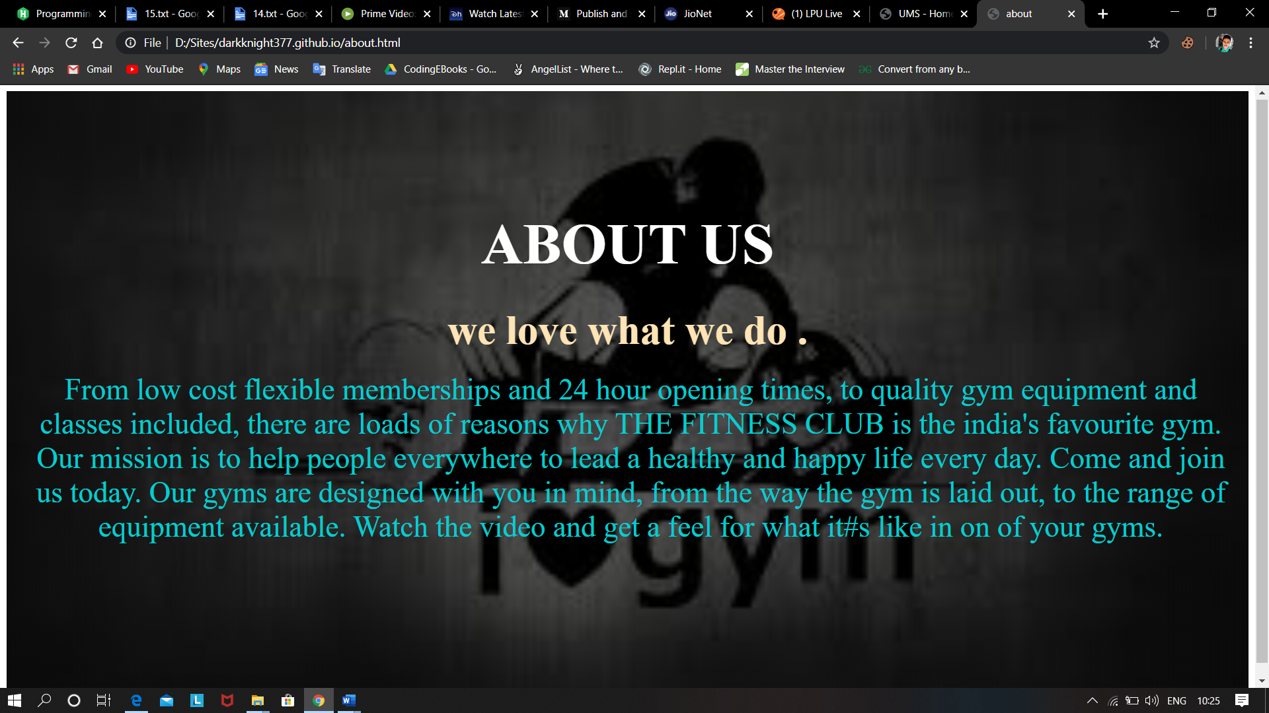 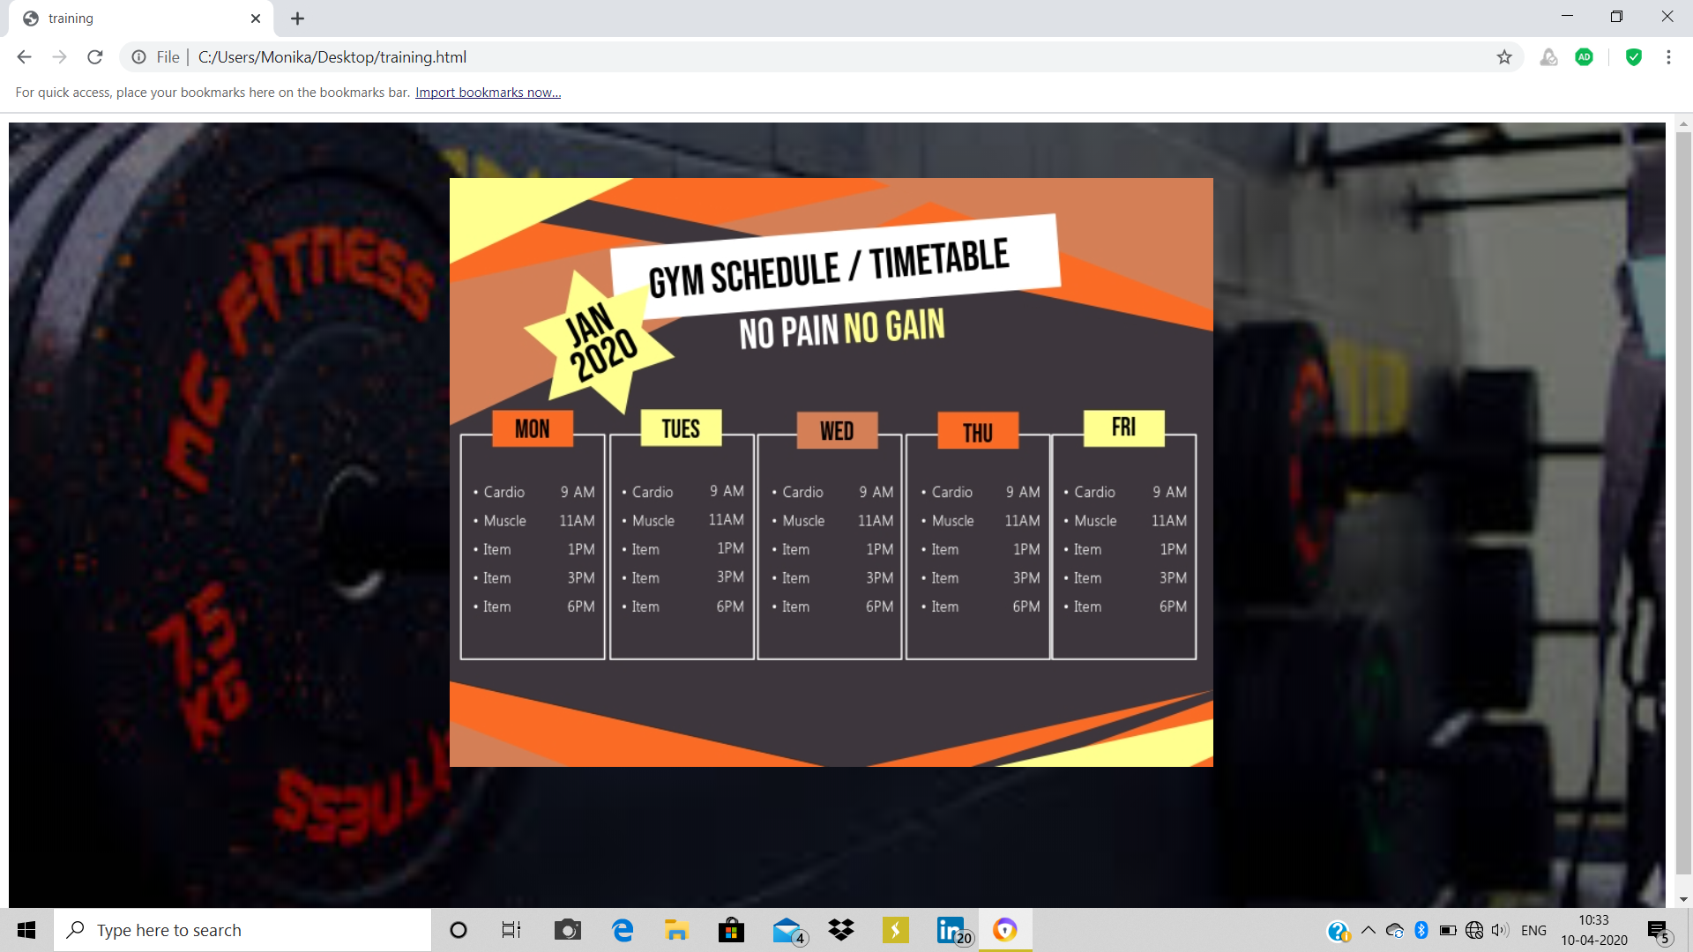

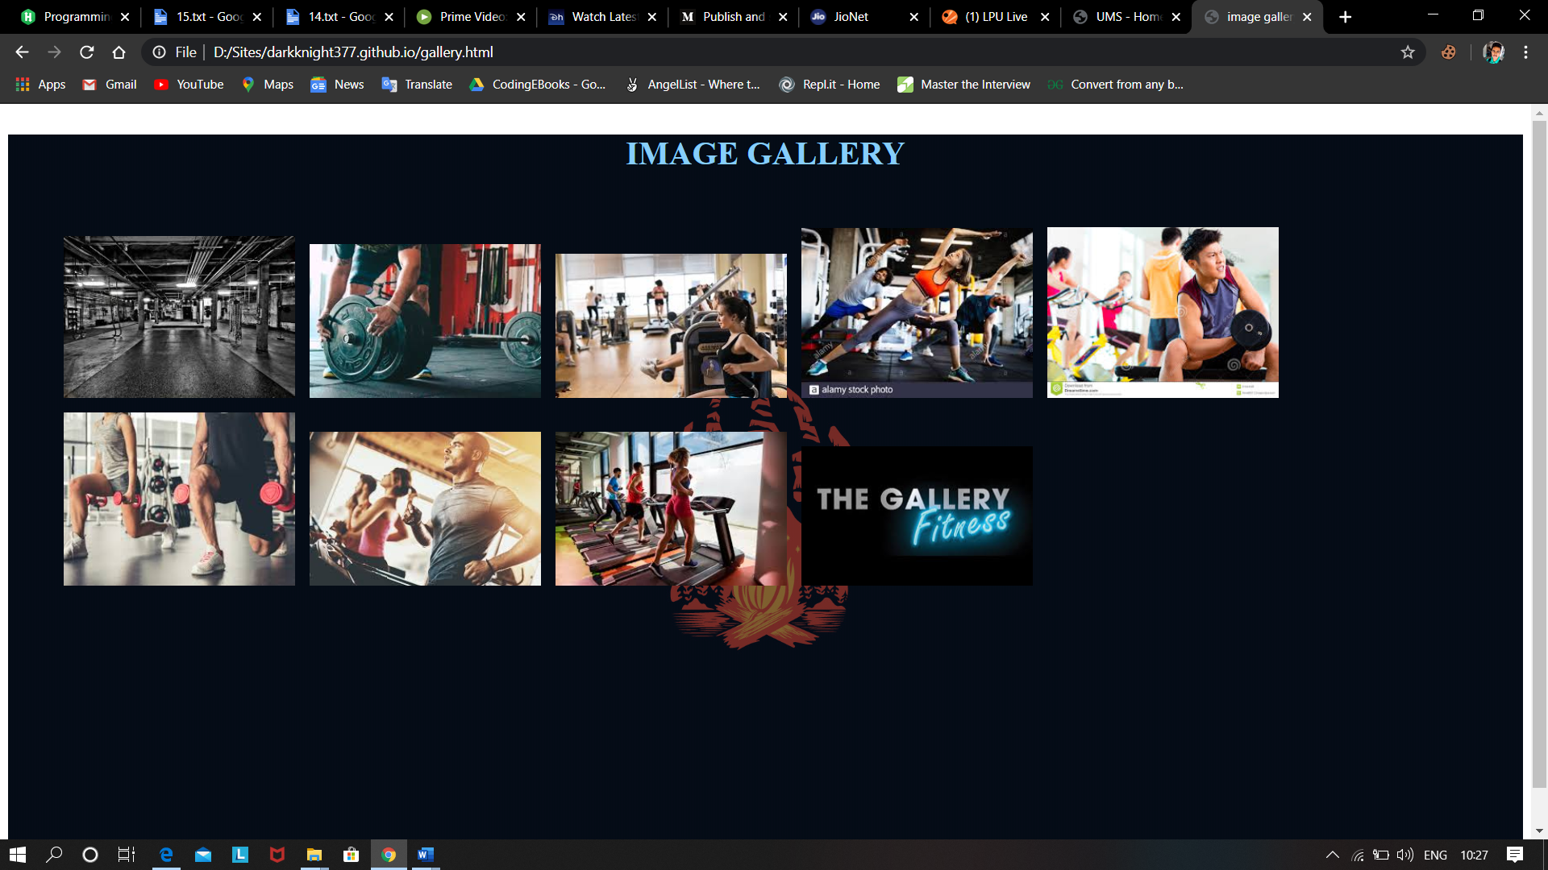

**Technology Used**

* HTML 5
* CSS
* JavaScript